Name: Kumar Sambhava
Branch: cse cybersecurity
Group: G4 3rd sem
PROJECT TITLE: ARP Spoofing Attack Demonstration
Project description: This project demonstrates an ARP Spoofing (ARP Poisoning) attack in a controlled virtual lab to highlight security weaknesses in the Address Resolution Protocol (ARP). Since ARP does not authenticate responses, it can be exploited to perform Man-in-the-Middle (MITM) attacks.
1.ARP table before communication
This section shows the ARP table before any active communication with the gateway. Only previously known IP–MAC address mappings are present. This represents a normal and stable ARP state.

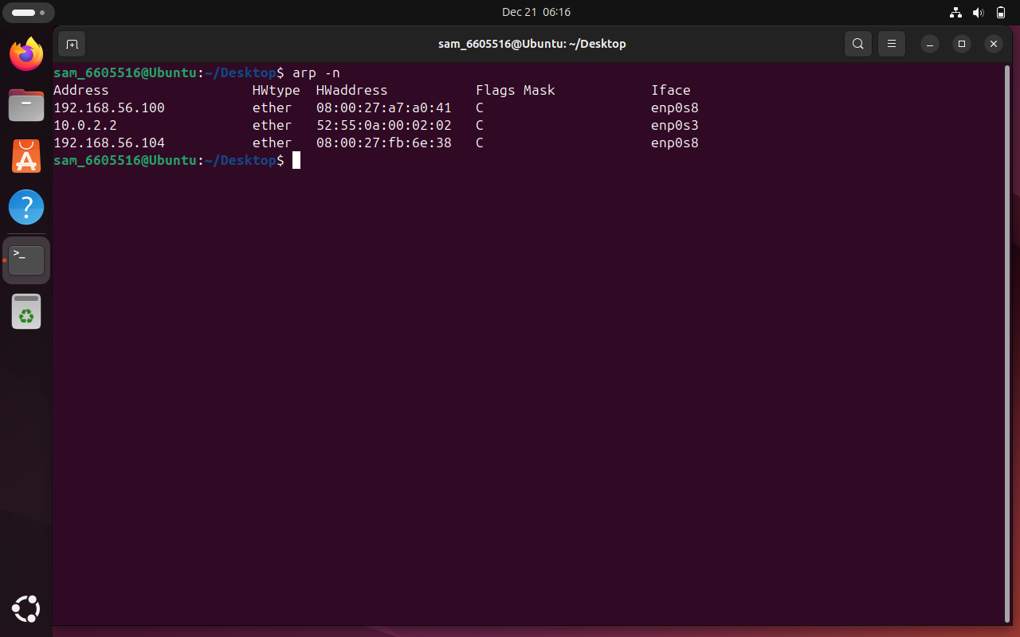

2. ARP table after normal ping
After the communication attempt, the ARP table updates automatically. New entries appear as the system resolves MAC addresses for recently contacted IPs. This reflects dynamic ARP behaviour in real-time network communication.

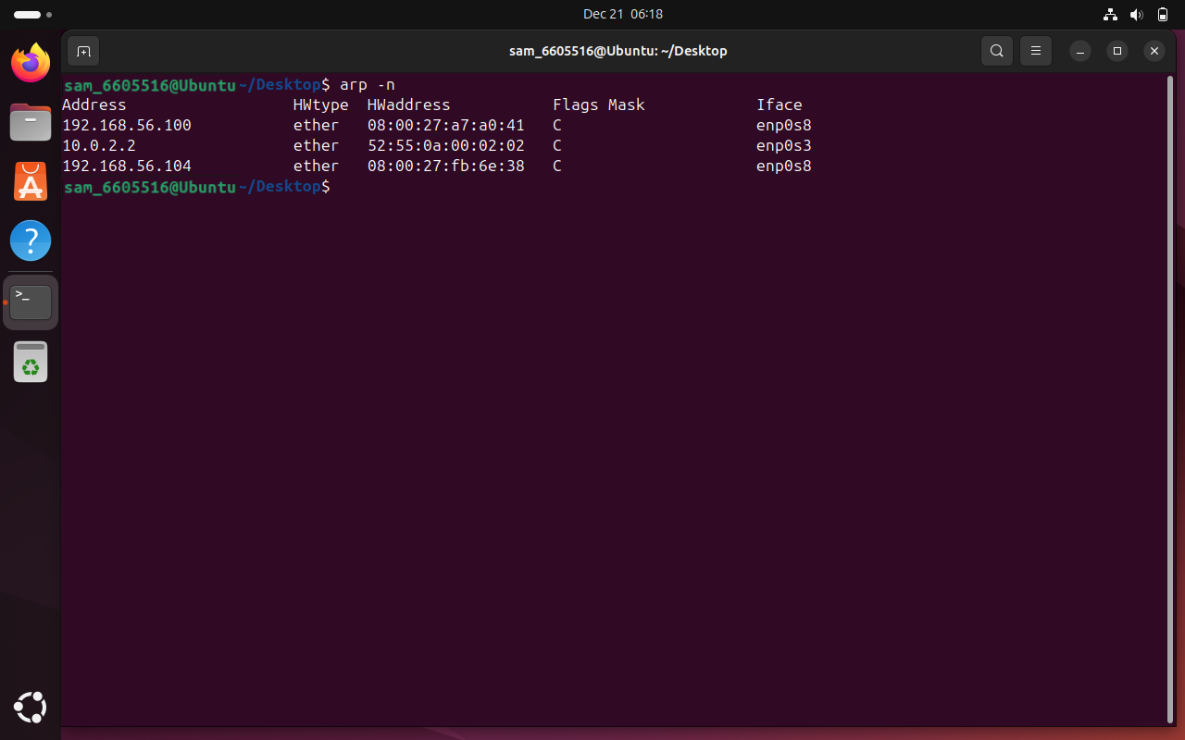

3.Successful ARP Spoofing Evidence
In this stage, abnormal network behaviour is observed. When a ping request is sent to the gateway (192.168.56.104), ICMP Redirect Host messages appear. This indicates routing confusion or possible ARP spoofing activity, where traffic is being redirected incorrectly.

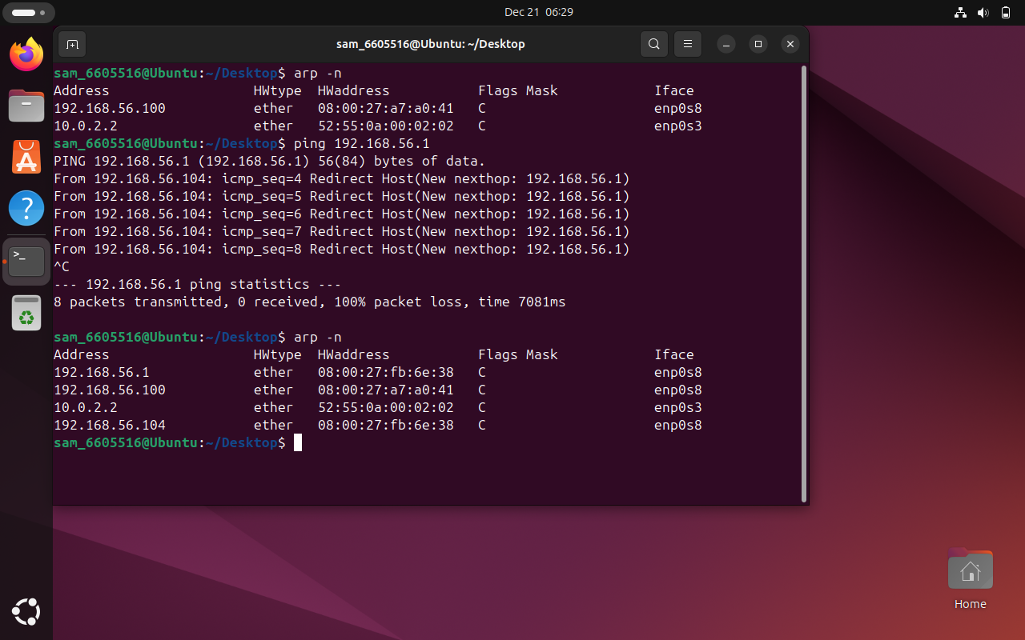

4.CONCLUSION
• ARP dynamically maps IP addresses to MAC addresses.
• Network communication triggers ARP table updates.
• ICMP Redirect messages suggest abnormal routing behaviour.
• Monitoring ARP tables is important for detecting network issues and security threats.

